**JAVA - ASSIGNMENT NO -01**

1. **Write a program to print Hello World.** [**Compile and run**](https://youtu.be/Idqa30mZbko) **it using command prompt.**

class Program{

public static void main(String[] args){

System.out.println("Hello World");

}

}

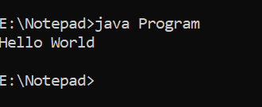

**2.Write a** [**program to declare a variable**](https://youtu.be/PVJwfMH_hxc) **named rollNo of integer type. Assign it a value (let say 100) to it and print the following statement roll no = 100 .**

class rollNo {

public static void main(String[] args){

int rollNo=100;

System.out.println("RollNo ="+rollNo);

}

}

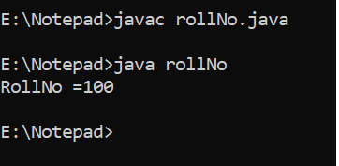

**3.Find the result of following expressions. You need to determine the** [**primitive data type**](https://youtu.be/1ydNljiCSX0) **of the variable by looking carefully the given expression and initialize variables by any random value.**

**A. y = x2 + 3x - 7 (print value of y)**

**B. y = x++ + ++x (print value of x and y)**

**C. z = x++ - --y - --x  +  x++ (print value of x ,y and z)**

**D. z = x && y || !(x || y)  (print value of z) [ x, y, z are boolean variables ]**

class man{

public static void main(String args[]){

int x = 20;

System.out.println("Value of x is "+x);

int y = x*2 + 3*x - 7;

System.out.println("Answer of A is Y = x2 + 3x - 7 = "+y);

y = x++ + ++x;

System.out.println("Answer of B is Y = x++ + ++x");

System.out.println("x is "+x+" and y is "+y);

int z = x++ - --y - --x + x++;

System.out.println("Answer of C is z = x++ - --y - --x + x++");

System.out.println("x is "+x+", y is "+y+" and z is "+z);

boolean a = true;

boolean b = false;

boolean c = a && b || !(a || b);

System.out.println("Answer of D is z = x && y || !(x || y)");

System.out.println("z is "+c);

}

}

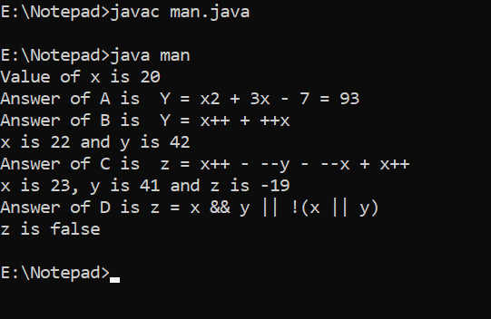

**4.Write a program that initializes 2 byte type of variables. Add the values of these variables and store in a byte type of variable. [Note:** [**primitive down casting**](https://youtu.be/CjQ07STtWpQ) **is required in this program] .**

class www{

public static void main(String [] args){

byte a1=100;

byte c1=125;

byte n = (byte)(a1+c1);

System.out.println("byte="+n);

}

}

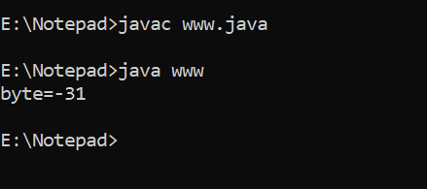

**5. Find out Simple Interest**

class dog{

public static void main(String args[])

{

float P = 2000;

float Q= 5;

float R = 4;

System.out.println("principle amount is = " + P);

System.out.println("entered rate is = " + Q);

System.out.println("time period is " + R);

float SI = (P * Q * R) / 100;

System.out.println("Simple interest = " + SI);

}

}

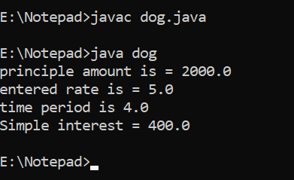

**6.Write a program that takes user’s name as** [**command line argument**](https://youtu.be/NCYXNGjxEjs) **and prints Welcome <entered user name>.**

class commandline{

public static void main(String args[]){

System.out.println("Welcome " );

System.out.print(args[0]);

}

}

